5.15 二叉树如图：

前序遍历:15-5-7-20-18-16-25

中序遍历:5-7-15-16-18-20-25

后序遍历:7-5-16-18-25-20-15

5.25 根据题意可得：

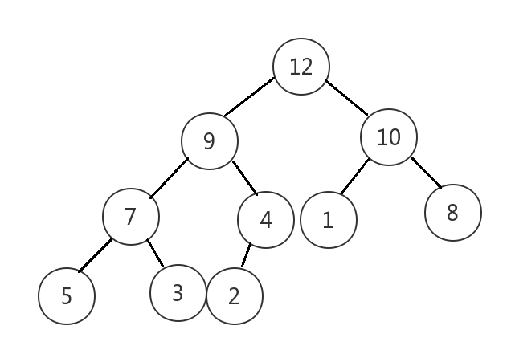

5.28 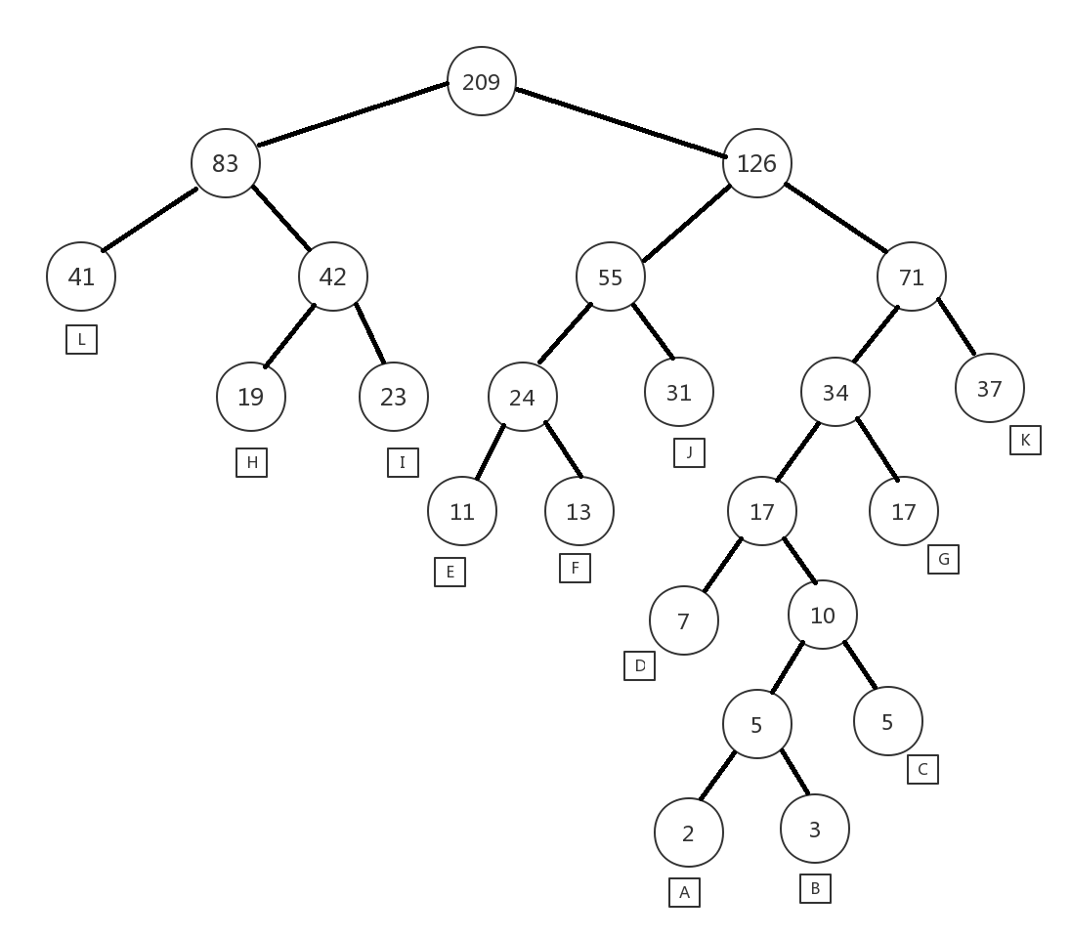

哈夫曼树如上图，根据左0右1的取法，可得各个字母的编码：

A:1100100 B:1100101 C:110011 D:11000 E:1000 F:1001 G:1101 H:010 I:011 J:101 K:111 L:00

6.7 根据题意可得：

|  |  |  |  |  |  |  |  |  |  |  |  |  |  |  |  |  |
| --- | --- | --- | --- | --- | --- | --- | --- | --- | --- | --- | --- | --- | --- | --- | --- | --- |
| 结点下标 | 0 | 1 | 2 | 3 | 4 | 5 | 6 | 7 | 8 | 9 | 10 | 11 | 12 | 13 | 14 | 15 |
| 标号 | 0 | 1 | 2 | 3 | 4 | 5 | 6 | 7 | 8 | 9 | 10 | 11 | 12 | 13 | 14 | 15 |
| 父指针 |  | 0 | 0 | 0 | 0 | 0 | 0 | 6 | 0 | 0 | 0 | 9 | 0 | 0 | 12 | 0 |

图如下：

